HACK N CODE 3

Team ID: 27

Team Members: Harsh Donga

Aziz Rangwala

Aman Patwa

Name of Project: WASTE MANAGER

Github link : https:github.com/harshdonga/wastemanager

IDEA OF THE PROJECT

Awareness and motivation about anything is really important! To keep people continuing what has to be done, a portal has been developed by us.

We have tried to implement a manager at government’s end! So, for a good deed ,we try to suffice reimburse with a credit!

Detailed Description:

Basically, a user can upload photo of waste it has spotted. The user’s current location (specific latitude longitude, is queried to mapquestAPI) is stored in database.

Now the picture goes to Django backend and it is evaluated as organic or recyclable using keras built on top of tensorflow.

This is spotted at admin interface, which is particular in specific city.

Admin can see the detailed view and a route is generated for the collection truck carry all the user locations that is A-B-C-D, not only just A to B.

This evaluation using DL credits some government credits to the user.

Now the user can use this credits to many applications shown in screenshot below.

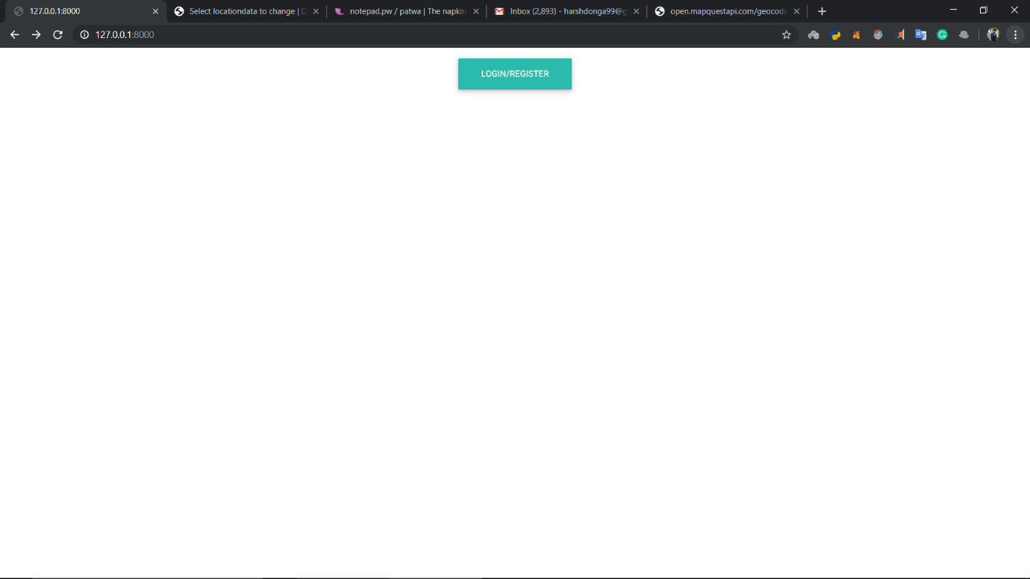

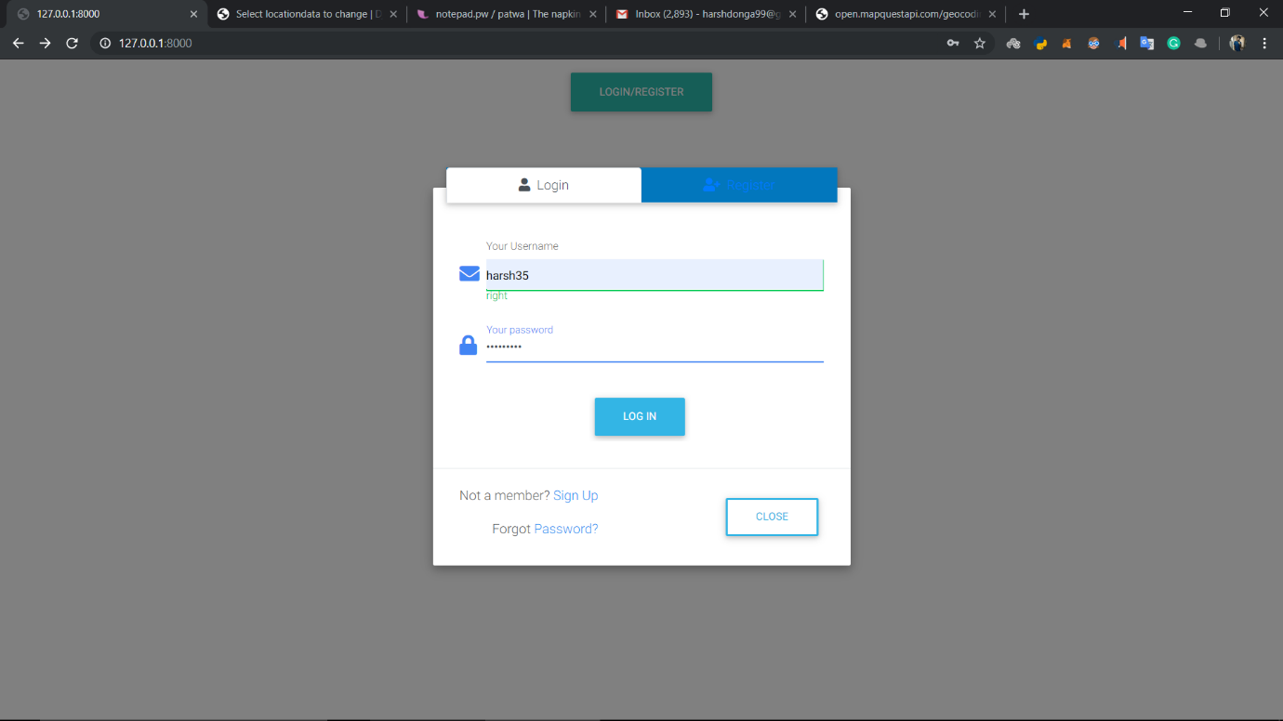

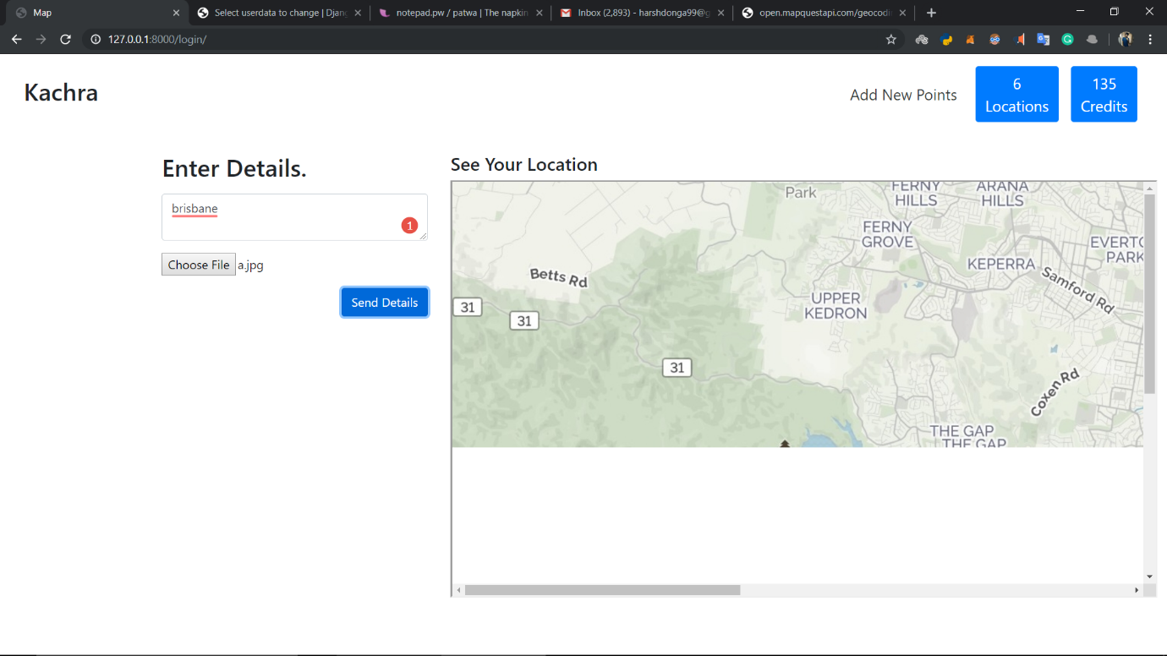

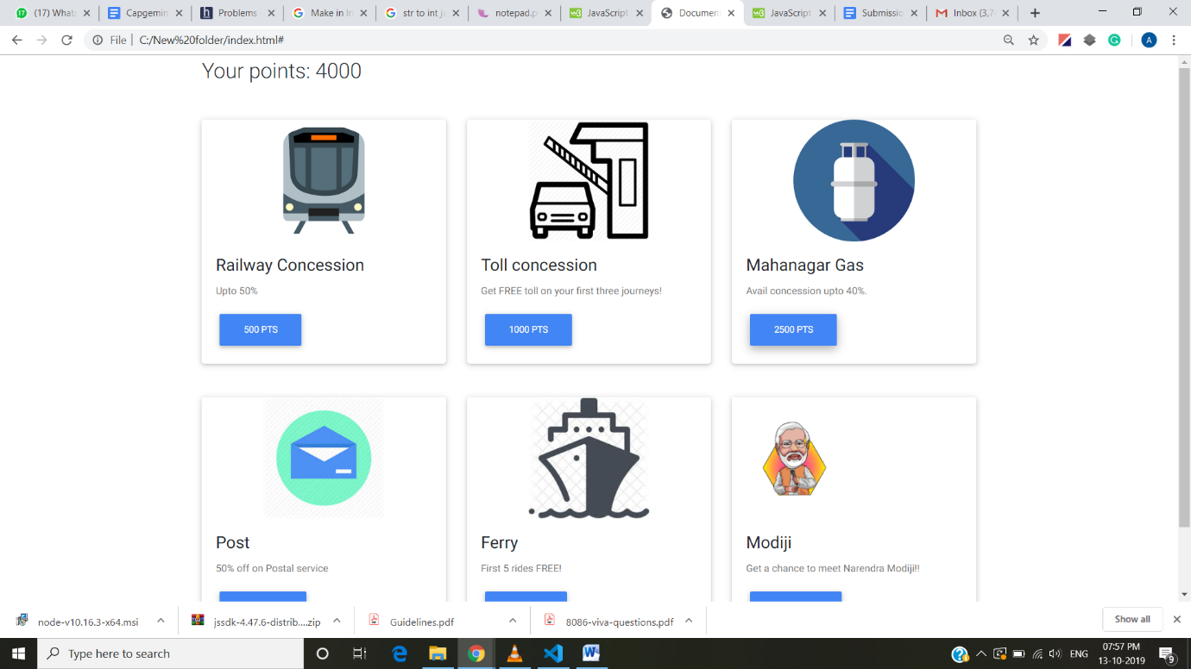

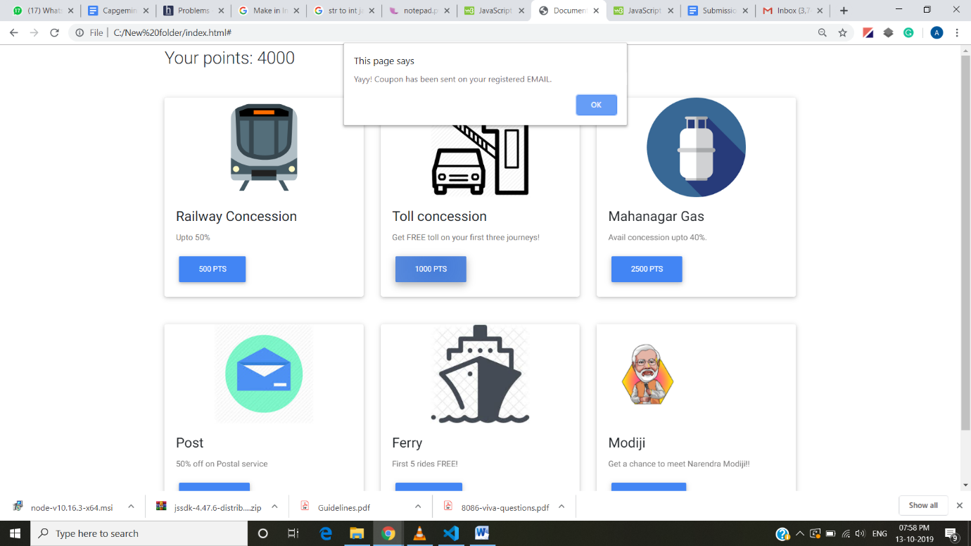

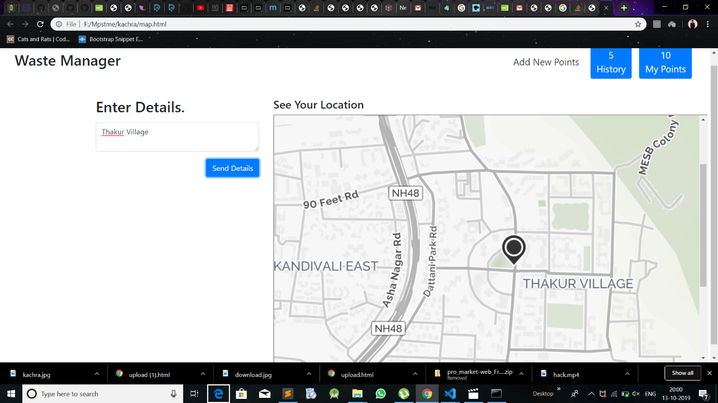

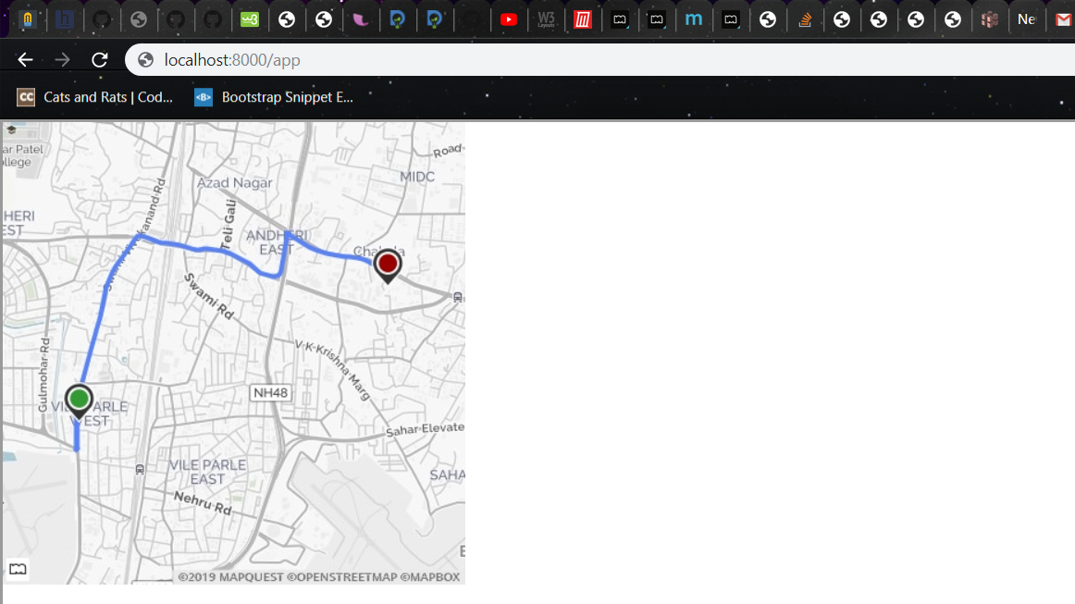

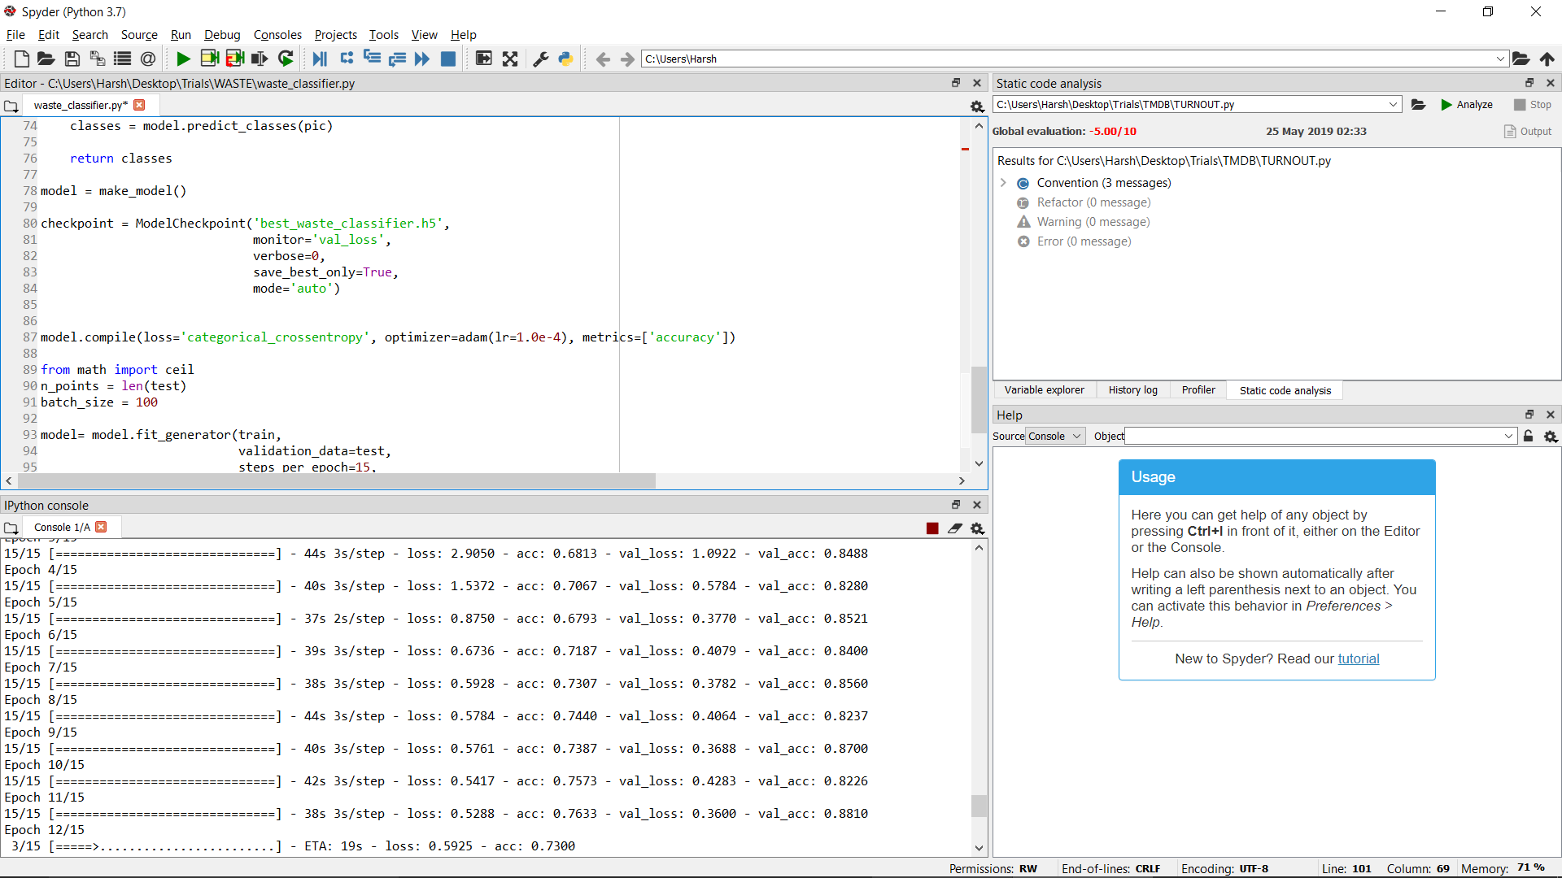

TECHNOLOGY STACK :

Django

Keras

CSS

Jquery

HTML

JavaScript

BootStrap

FUTURE SCOPE